|  |  |  |  |  |  |  |
| --- | --- | --- | --- | --- | --- | --- |
| Description: Vertical full colour positive | Safety Bay Senior High School | | | | | |
| **CHEMISTRY UNIT 1 & 2** | | | | | | |
| **Test** | | | | | | |
| **Acids and Bases** | | | | | | |
|  | | | | | | |
| **NAME:** | | |  | | | |
|  | | |  | | | |
| **Time allowed for this paper** | | | | | | |
| Reading time: | | 5 minutes | | | | |
| Working time: | | 50 minutes | | | | |
| **Structure of this paper:** | | | | | | |
| Section | | | Number of questions | Marks available | | Marks achieved |
| Section One: Multiple Choice | | | 15 | 15 | |  |
| Section Two: Short Answer | | | 8 | 23 | |  |
|  | | |  | | **Total** | ______ / 38 |

**Multiple choice. Answer on the separate sheet provided.**

1. All things that are acidic will eventually produce

a) OH  
 b) HCl   
 c) H3O+  
 d) H2O.

2. A 0.001M solution of HCl is

1. A weak acid solution.
2. A concentrated acid solution.
3. A dilute acid solution.
4. Neutral.

3. A base that dissociated entirely into metal ions and hydroxide ions is known as a:

1. Strong base.
2. Weak base.
3. Concentrated base.
4. Dilute base.

4. Compared to strong acids, weak acids produce __________ ions and conduct electricity

__________ efficiently.

1. fewer, less.
2. more, more.
3. more, less.
4. fewer, more.

5. Ammonia is classified as a weak base, which means it is only partially ionised in solution.

What is the likely value for pH of a 0.010 mol L-1 solution of ammonia?

1. 2

b) 5   
 c) 9   
 d) 13

6. A test that could safely distinguish a strong base from a weak base is

a) taste.  
 b) touch.  
 c) litmus paper.  
 d) electrical conductivity.

7. Caustic soda, NaOH, is found in

a) fertilizers.  
 b) beverages.  
 c) oven cleaners.  
 d) toothpaste.

8. The hydronium ion, H30+ is a water molecule that has

a) lost a proton.  
 b) gained a proton.  
 c) gained a neutron.  
 d) lost an electron.

10. The hydroxide ion concentration of a solution equals 10–(14–pH). The hydroxide ion concentration of a solution with pH of 4 equals:

a) 1010.  
b) 10–10.  
c) 104.  
d) 10–4.

For questions 11 and 12 refer to the indicator chart below.

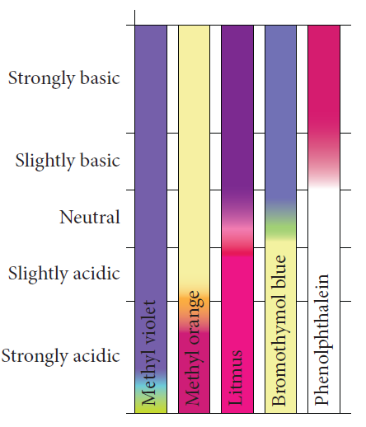

11. A solution was tested with all five indicators. Two of the indicators turned yellow. The solution can be described as:

a) strongly acidic.  
 b) slightly acidic.  
 c) slightly basic.  
 d) strongly basic.

12. A student wanted to test the pH of a blue copper(II) carbonate solution. Which indicator would be the correct one to use?

a) Any indicator.

b) None of the indicators.

c) Phenolpthalein.

d) Bromothymol blue.

13. Which of the following correctly shows the ionic equation (i.e. only reacting species) for the reaction between sodium carbonate solution and hydrochloric acid?

a) Na2CO3 (aq) + 2 H+ (aq) → 2 Na+ (aq) + CO2 (g) + H2O (l)

b) NaCO3 (aq) + 2 H+ (aq) → Na+ (aq) + CO2 (g) + H2O (aq)

c) CO32- (aq) + 2 H+ (aq) → H2O (l) + CO2 (g)

d) CO32- (aq) + 2 Na+ (aq) + 2 H+ (aq) → 2 Na+ (aq) + CO2 (g) + H2O (l)

14. When the leaves of red cabbage are boiled in water, the liquid collected can be used as   
 an indicator. When the red cabbage juice is added to water it turns purple, when it is   
 added to sodium hydroxide it turns green and when it is added to hydrochloric acid it   
 turns red. Which of the following correctly shows the colours you would expect to   
 observe when red cabbage juice is added to the solutions below?

**Lemon juice Bicarb soda Vinegar**

a) red green red

b) red green purple

c) purple red purple

d) red red purple

15. Two solutions of equal concentration, A and B, have a pH of 3 and 6 respectively. Which of the following statements about the solutions is/are true?

1. They will show the same colour in universal indicator.
2. The concentration of H+ is higher in B than it is in A.
3. B is a weaker acid than A.

a) (ii) only  
 b) (iii) only  
 c) (i) and (ii) only  
 d) (i), and (iii) only

**Short answer.**

1. Explain the difference between a polyprotic acid and a monoprotic acid. (1 mark)

2. Explain what is meant by the Arrhenius model of acids. (2 marks)

3. Apply the Arrhenius model to explain what happens to sulphuric acid when it is added to water.

Use formulae and equation styles to do this. (4 marks)

4. A student has 25 mL of a 0.10 mol L–1 hydrochloric acid solution. How much water must be added   
 to prepare a 0.025 mol L–1 solution? (2 marks)

5. Write a balanced equation **and** an ionic equation for the reaction that occurs when sulphuric acid   
 is added to potassium hydroxide solution. (4 marks)

6a. What products are formed when a solution of hydrochloric acid is added to a solution of sodium   
 hydrogen carbonate? (1 mark)

b. Write a balanced **and** an ionic equation for this reaction. (4 marks)

7. Calculate the volume of 0.500molL-1 of hydrochloric acid (HCl) that reacts completely with 25.0   
 molL-1 calcium hydroxide (Ca(OH)2. (4 marks)

8. Rank the following according to their property mentioned. (1 mark)

0.10 mol L-1 HCl(aq), 0.20 mol L-1 NaOH(aq), 0.10 mol L-1 H2SO4(aq),

pH

Lowest Highest